**MYSQL STRING FUNCTIONS- REPLACE, REPEAT, REVERSE, RIGHT, LEFT, RPAD, LPAD**

Exp. No.: 20

Date:

**AIM:**

To implement Replace, Repeat, Reverse, Right, Left, Rpad and Lpad String Functions using MySQL’

REPLACE():

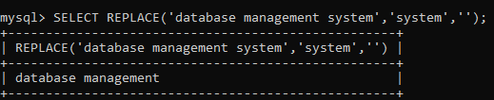

REPEAT():

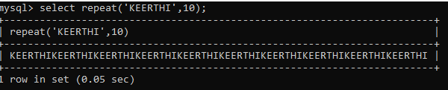

REVERSE():

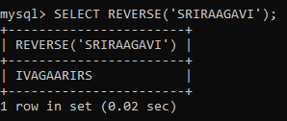\

RIGHT():

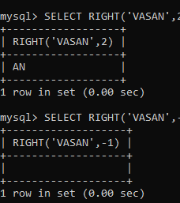

Left():

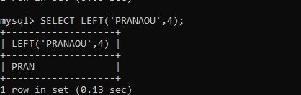

Rpad():

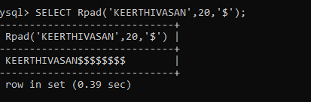

Lpad():

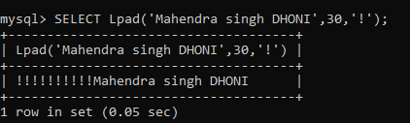

Ascii():

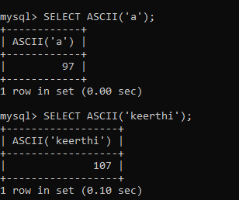

BIN():

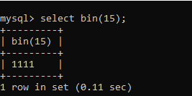

OCT():

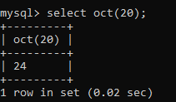

**RESULT**: Thus the String Functionssuch as Replace, Repeat, Reverse, Right, Left, Rpad and Lpad are executed successfully.